精 密 光 學 鍍 膜 工 藝 技 術
Plastic Lens AR coating (Material: PC、PMMA、PET、ABS、COP、Zeonex series)
- 435~650nm,R(abs)<0.5%
- @450~650nm, R(ave)<0.5% ; @750nm, R(abs)<2%; @850nm, R(abs)<4%
Size: Diameter 3~150mm
High Temperature: 85~115⁰C (with different material)
Glass Lens for Automobile
- 450~850nm, R<0.8%
- @450~500nm, R<2% ; @500~650nm, R<0.5%; @650~750nm, R<0.8%; @750~850nm, R<2%
耐摩擦測試: 豬鬃刷/牙刷, 0.5Kg, 來回500次, Contact Angle>100deg
Filter - Band PASS Filter:
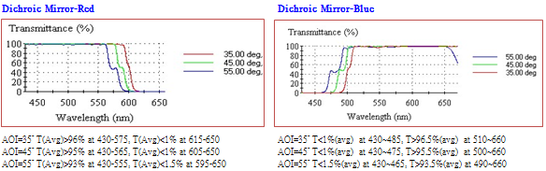
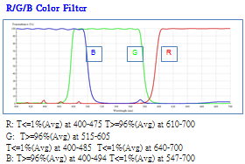
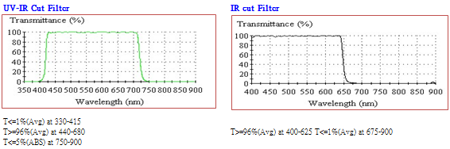
Filter - Dual Band PASS Filter
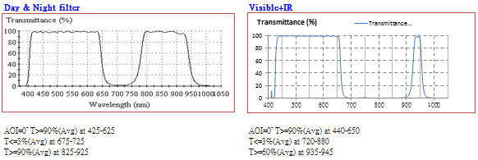
Filter - Narrow Band PASS Filter
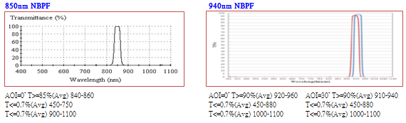
High Reflectivity Mirror
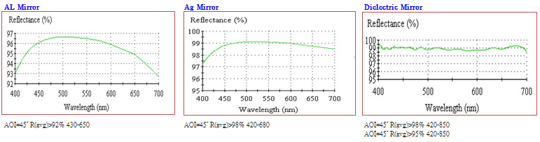
HUD Combiner & Mirror
AOI=45⁰, @430~650nm, R(ave)=50+/-5%

